**AIO- The All-in-one Place**

Portal 3

**Version:** 1.0.0

**Status:** In development

**Goal:** To craft a customised solution for job seekers, aimed at enhancing their market positioning to successfully secure employment based on their unique skills, ultimately fortifying their income potential.

**Description/Features :** Welcome to AIO Portal 3, the premier platform designed to assess the current status of job seekers and serve as a centralised hub for job applications, offering an all-in-one solution for career advancement.

· For career aspirant :

- Explore personalised Job recommendations aligned with your skills and other relevant factors, intelligent predicted by Ai models

- Upload your Resume/CV to gain insights into your standing compared to others, with a comprehensive analysis guided by expert suggestions and NLP-based Ai models .

- Access all job postings on the site in one centralised location for a seamless job search experience.

**Tools used** :

* Python
* Google Colab
* Scikit-Learn
* Vertex Ai (will be used for deploying Ai models and monitoring)
* spaCy
* Google Cloud
* Google Trans library
* Project is still in development thus more toold would be added if using.

**Snapshots of features** :

1. Job Designation predictor

* Input :-

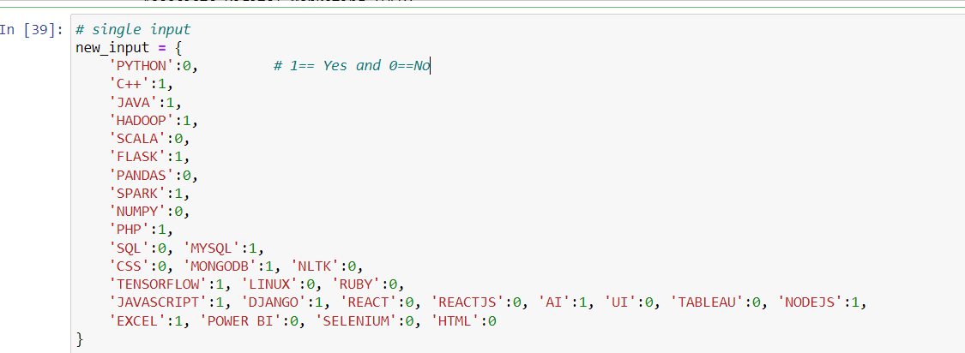

* Output :-

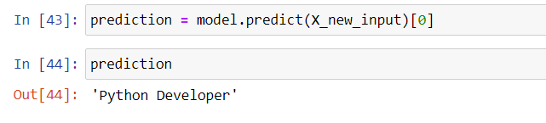

1. Resume Analyser( still in development phase..)

* input :- An file named “Alice Clark.pdf” is uploaded

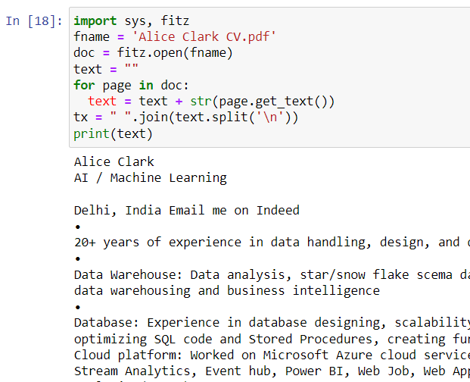

* output :-

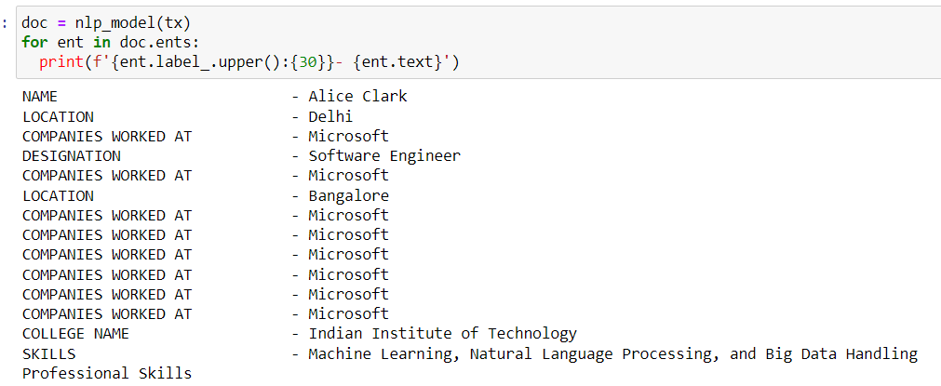

1. All site job postings in one central location

( This section is under development……..)